# **Putting the "M" in HTML**

So the "M" in HTML stands for "Markup", but what does Markup really mean? Essentially, it means to annotate a document with extra information. Things like where different sections and paragraphs begin and end, which part is the title, which things should be emphasized and so on.

There are many ways to markup a document, but HTML borrows a technique from an ancestor language, SGML ([Standard Generalized Markup Language](https://en.wikipedia.org/wiki/Standard_Generalized_Markup_Language)), which uses angle brackets ("<" and ">") to separate the annotations from the regular text. In HTML these annotations are called "tags".

For example, consider the following chunk of HTML code:

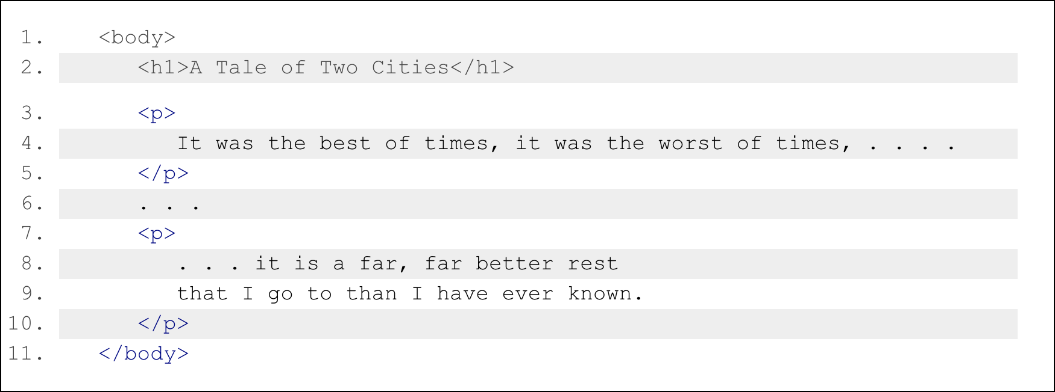

If you eliminated everything in between the angle brackets from the text, for most purposes it would still read the same:

A Tale of Two Cities

It was the best of times, it was the worst of times . . . .

. . .

. . . it is a far, far better rest

that I go to than I have ever known.

Once you know that everything in angle brackets is "meta-information", it leaves a lot of flexibility. You can put a lot of different things in between those brackets without any of it showing up (directly) in your finished document. And, though you don't usually see directly what's in those angle brackets, they can often have a big effect on what your Web page looks like as well as how it responds and interacts with you.